**NR292**: Independent Study: Inside an Ecosystem Monitoring Non-Profit

Morgan Swain

Final Portfolio

12/9/2022

I have completed my NR292 Independent Study with the Forest Ecosystem Monitoring Cooperative (FEMC). In total, I will be earning 3 credits through the Rubenstein School at the University of Vermont, with ~8-12 hours/week of associated work.

FEMC is a collaboration among universities, government agencies, and non-profits from seven Northeastern states. FEMC, in coordination with these organizations, shares and synthesizes forest ecosystem research and monitoring data, facilitates networking and partnership, and provides tools to help their stakeholders understand and manage forested ecosystems across the region.

My role at the FEMC was labeled as the Data Technician Intern, but my tasks spread far beyond just working with data. Throughout the semester, I collaborated with many different members of the cooperative, mainly reporting to the FEMC Data Specialist, Matthias Sirch, and FEMC Interim Director, Elissa Schuett. I also supported on site data collection with FEMC Research Technician, Alyx Belisle, and AmeriCorps Member, Hanson Menzies, conducting field sampling at the Proctor Maple Research Center meteorological station.

Below are the final deliverables for my four primary learning objectives:

1. **Data Management and Communication**

Working with Matthias, I have developed proficiency in data management best practices. Together, we explored the FEMC data archive, including the project meta data, past projects, and the backend of their database through Toad software. I have assisted Matthias with data entry, quality control checks, and computing summary statistics in R. To satisfy the requirements of the descriptive statistics, I have developed code in R for the 2021 Forest Health Monitoring summary statistics. I wrote lines 1546 through 1605 based on script Matthias and I had written together (lines 1270-1540). This portion of the script identifies the species with poorest crown health measurements by weighting each species' vigor, dieback, and defoliation and listing the species with lowest scores of all three metrics. Download the Forest Health Monitoring script with the following link: <https://www.uvm.edu/femc//attachments/project/999/FHMStats_20221101.zip>

As a student at UVM, I am extremely passionate about sustainability and environmental justice. Reflecting on exploring the FEMC Forest Health Monitoring Data and working on projects for the cooperative, this work has felt extremely fulfilling to me. I feel as though these results are essential for future generations to look back on and see factual evidence of a changing environment. I am very lucky to have been a part of this work and to assist in the data analysis of New England tree health.

1. **Field Sampling and Instrumentation**

I have supported on-site data collection by collaborating with Alyx and Hanson to conduct field sampling at the Proctor Maple Research Center meteorological station. I compiled photos, video tutorials, and descriptions of sampling techniques for MDN and NTN testing done at the Research Center in this document that will be available for FEMC staff for internal use:

<https://www.uvm.edu/femc/attachments/project/999/FEMC_PMRC_Tutorials.pdf>

Link to video tutorial of NTN testing that is available on the FEMC YouTube channel:

<https://www.youtube.com/watch?v=6r8B-qV5Tmk>

Working with Matthias, we spent a day in the woods behind the Spear Street Laboratories evaluating field protocols for the FEMC project: Regional Assessment of Browse and Its Impacts on Forest Vegetation. These protocols included the AVID (Assess Vegetation for Impacts from Deer) method, Ten-Tallest method, Twig Aging method, and a variety of indicator species methods. This evaluation was to provide estimates of effort required for FEMC stakeholders to make an informed decision of which method to perform on their property. As a Mathematics student, I found this work engaging and informative because it is not often that I get to work out in the field. I enjoyed every moment of being outside and relating the data I was seeing on my screen to observations in nature. It was also endearing how passionate and informed Matthias, Alyx, Hanson, and all the other workers are about Vermont’s ecosystems, including the species, pests, animals, and weather we experience here. I learned a lot by just being in their presence while they worked.

1. **Networking Skills**

As a part of the Women in STEM Club and serving as the Networking Chair, I have reached out to the President of the club, Isabelle Kressy, and attempted to plan a time in the Spring semester of 2023 for Elissa to speak on her experience in the field or about the FEMC in general to help increase engagement with women in science. To satisfy the requirements and connect this work my involvement as a senior Mathematics major at the University of Vermont, I created a presentation for the course I am taking this fall titled Math 273: Graph Theory. I related graphs with vertexes and edges to forest plots that FEMC has created throughout New England and New York as well as showcased the code I had written earlier in the semester. During this presentation, I also participated in development and outreach for the FEMC 2022 Annual Conference by providing classmates with information and a link to the Conference page. The link to the full presentation is found here:

<https://streaming.uvm.edu/private/videos/Lk7XVBk/>

I was present for multiple FEMC staff meetings and absorbed the tasks of each staff member. I have learned what it takes to run a small-scale environmental non-profit organization. There is a lot of dedication, passion, and support needed to run a cooperative such as this smoothly. Many of the workers do their tasks separately throughout the work week but can always come to each other with questions or ideas. The weekly meetings were a great opportunity to bring up topics people were interested in and help one another. I believe that this work at the FEMC has prepared me for a post-undergraduate life and to take my first steps into the corporate world. I have made long lasting connections with staff members and gained knowledge on how to be a productive team member.

1. **Science Communication**

I have built experience communicating science to a broad stakeholder audience. From my previous position as a digital marketing intern, I have experience writing blogs, creating social media posts, and analyzing data for websites. I have created multiple original Instagram and Facebook posts on Canva that the FEMC has shared online:

* Announcing registration opening for the 2022 Annual conference

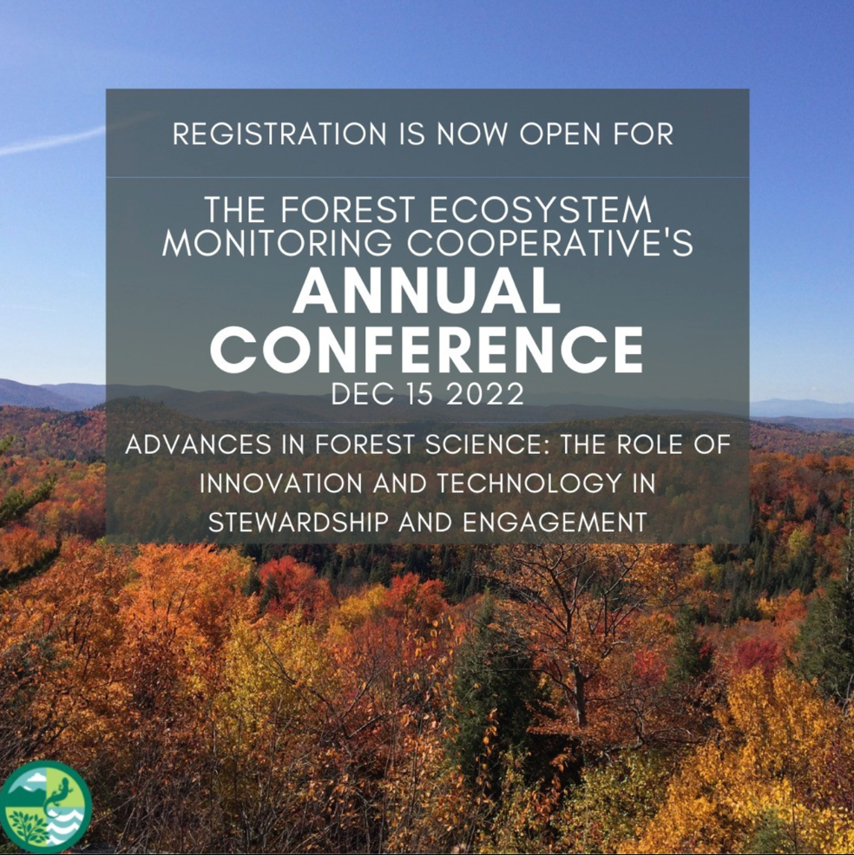

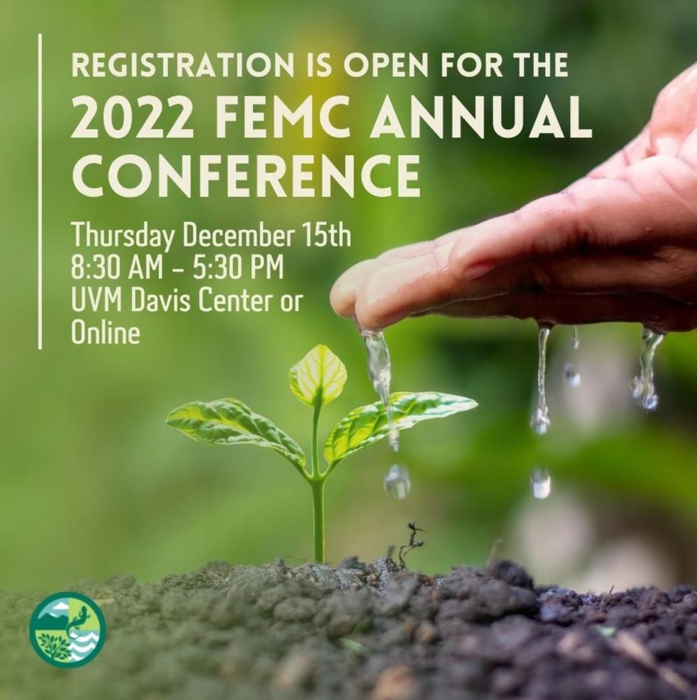

* Announcing the plenary speaker for the conference and providing readers with a short description of his work

* Announcing the three panel discussion speakers following the plenary session, a short description of their work, and the times they will be speakers

* Announcing the last day to register for the Annual Conference

